NAME: PAVITHRA K COURSE CODE: CSA0716
REG NO: 192411027 COURSE NAME: COMPUTER NETWORK
1. Missing OSI Layers
Concept map:
Application → Presentation → Session → Transport → Network → Data Link → Physical
Missing layers:
- Session Layer
- Data Link Layer
Concept Map
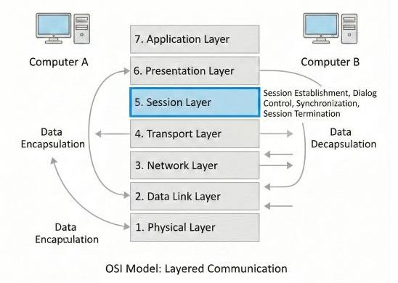
Analysis
- Session Layer: Establishes, manages, and terminates communication sessions between applications. It provides synchronization points so communication can resume after failures.
- Data Link Layer: Converts packets into frames, performs error detection (CRC), and controls communication between directly connected devices.
These layers are essential because the Session Layer maintains orderly communication, while the Data Link Layer ensures reliable local delivery. Together they support end-to-end reliability.
2. Data Units and OSI Layers
Concept Map
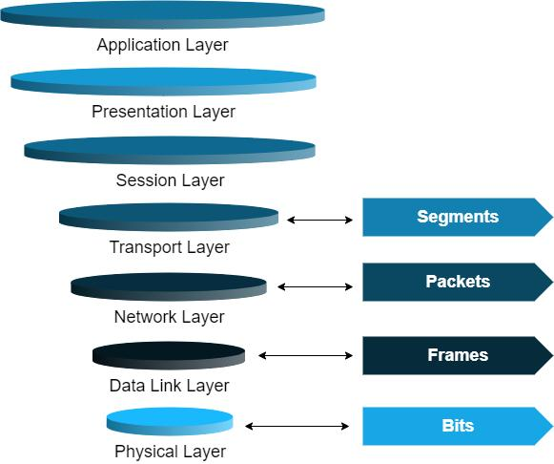
Mapping
OSI Layer | Data Unit
Transport | Segment
Network | Packet
Data Link | Frame
Physical | Bits
Analysis
Data is encapsulated as it moves downward through the OSI model:
- Application data → Segment: Transport layer adds port numbers and reliability information.
- Segment → Packet: Network layer adds IP addressing for routing.
- Packet → Frame: Data Link layer adds MAC addresses and error-detection fields.
- Frame → Bits: Physical layer converts the frame into electrical, optical, or radio signals.
This transformation allows data to be routed globally, delivered locally, checked for errors, and transmitted over the physical medium.
3. MAC Address and IP Address Relationship
Concept Map
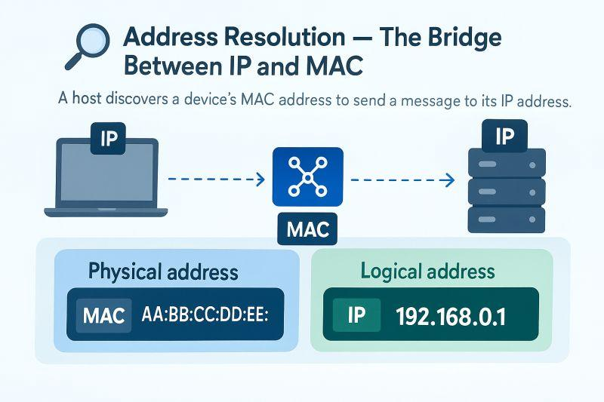
Analysis
- IP Address (Network Layer): Identifies the destination across different networks and enables routers to forward packets globally.
- MAC Address (Data Link Layer): Identifies devices on the local network and enables delivery between directly connected nodes.
Complete delivery process:
- The sender creates a packet with the destination IP address.
- Routers use the IP address to choose the next path.
- At each hop, the packet is placed into a frame containing the appropriate MAC addresses.
- The final router delivers the frame to the destination device using its MAC address.
Thus, IP provides global routing, while MAC provides local delivery. Both are required for successful end-to-end communication.
4. Error Control Interaction
Concept Map
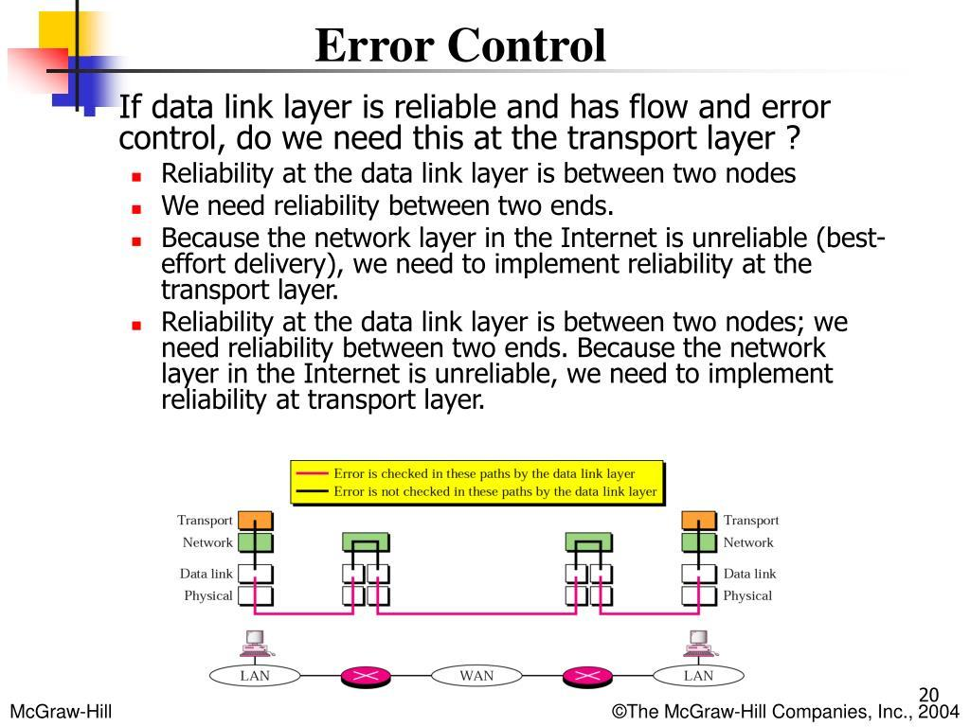
Analysis
- Data Link Layer – Error Detection: Uses mechanisms such as CRC or checksums to detect corrupted frames on a local link.
- Transport Layer – Error Correction/Recovery: Uses acknowledgements, sequence numbers, timeouts, and retransmissions (for example, TCP) to recover lost or corrupted data end-to-end.
Interaction:
- Data Link detects errors quickly on a single hop.
- Transport ensures the complete data stream arrives correctly across the entire network.
- If a frame is damaged and not recovered locally, the Transport layer requests retransmission.
This layered approach improves reliability by combining fast local error detection with end-to-end recovery mechanisms.
5. Concept Map for Web Browsing
Concept Map
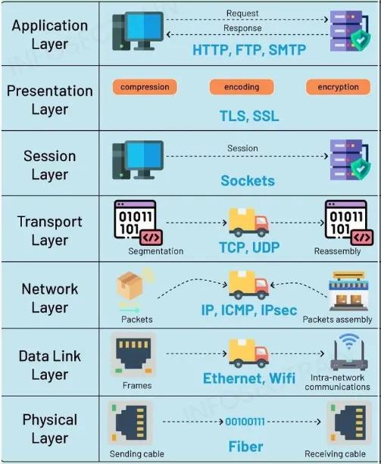
Analysis
During web browsing:
- Application: HTTP/HTTPS requests web pages.
- Presentation: Encrypts and formats data (TLS, encoding).
- Session: Maintains the communication session.
- Transport: TCP provides reliable delivery.
- Network: IP routes packets across networks.
- Data Link: Ethernet or Wi-Fi frames the data.
- Physical: Transmits bits over cable, fiber, or radio.
Failure impact:
- Physical failure: No signal; all higher layers fail.
- Data Link failure: Frames cannot be delivered locally.
- Network failure: Packets cannot reach the destination.
- Transport failure: Reliable connection cannot be established.
- Application failure: Web page cannot be displayed even if lower layers work.
A problem in a lower layer generally affects all layers above it.
6. Troubleshooting Using the Concept Map
Given
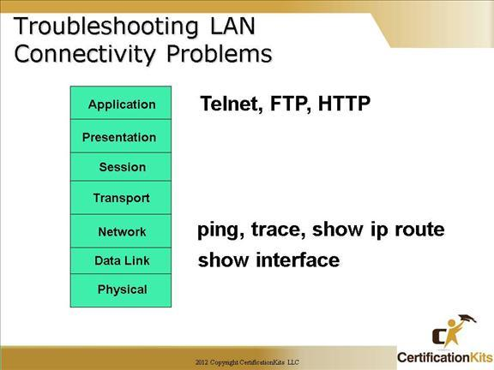
Analysis
The symbols indicate:
- Physical ✔: Cables, signals, or wireless connectivity are working.
- Data Link ✔: Frames are exchanged successfully on the local network.
- Network ✖: IP routing or addressing is failing.
- Transport ✖ and Application ✖: These fail because they depend on the Network layer.
Likely causes:
- Incorrect IP address or subnet mask.
- Missing or incorrect default gateway.
- Router failure.
- Routing table misconfiguration.
- Blocked IP traffic.
How the concept map helps:
By showing that the lower two layers are functioning, the concept map narrows troubleshooting to the Network layer. This avoids unnecessary checks of cables or applications and helps locate the fault more quickly.

